|  |
| --- |
|  |
| System Analysis and Design |
|  |

**Final Lab Report**

**Project Name**: AUTOMATED PARKING MANAGEMENT SYSTEM

AUTHORED BY:

Saadman Malik (154420)

Fardin Saad (154419)

**System Analysis and Design**

**Introduction:**

Our project for this semester’s CSE 4407 System Analysis and Design Course is Automated Parking Management System. This software allows the user to park their vehicles in a systematic way in the parking lot by assigning a parking slot provided they insert the Vehicle Bluebook. The users receive a parking ticket at the time of parking and while leaving they receive a cash memo generated by the system in which they have to pay their parking bill. This parking bill is generated depending upon the time the car is parked.

**Activity Planning:**

The following table shows the list of activities along with their timings. Each activity is indicated by a character symbol which is used to show their sequence in the Gantt chart and the PERT diagram.

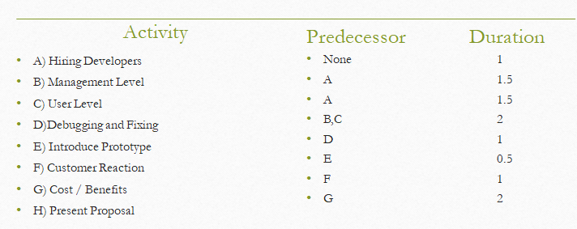

**Gantt Chart:**

The Gantt chart shows the sequence and the estimated start and end time of the activities that have been listed in the Activity Planning table. The horizontal axis represents duration in weeks and the vertical axis represents the numerous tasks that need to be carried out over the time period. Different tasks require different amount of time it is a very efficient method for planning out concurrent activities as well simultaneous activities

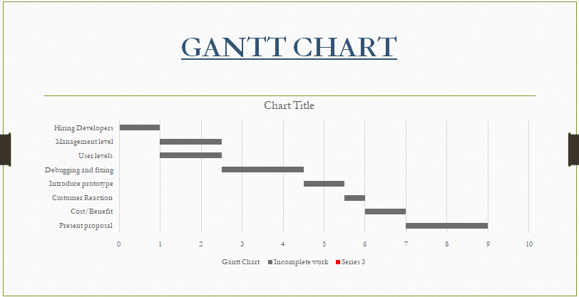

**PERT DIAGRAM:**

The PERT diagram is a convenient tool for displaying the sequence of activities and the maximum duration that may be required in order to complete a project. The maximum duration can be found by determining the Critical path. The Critical path is ABDEFGH.

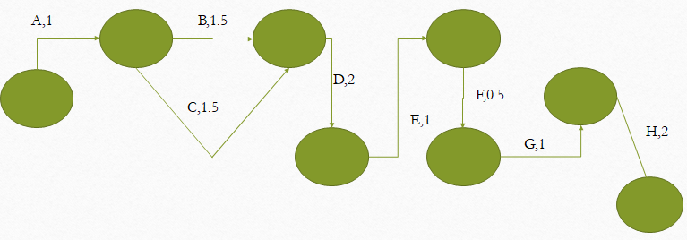

**DATA FLOW DIAGRAMS**

Data flow Diagrams graphically characterize the data flows and processes in a system. The Context Diagram is the highest level in a Data Flow Diagram. And the Diagram 0 is the explosion of the Context Diagram. These two diagrams are given below:

**Context diagram:**

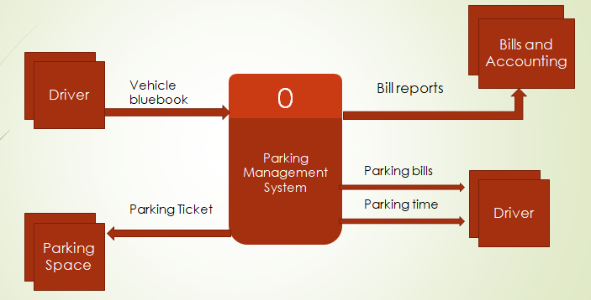

**Diagram 0**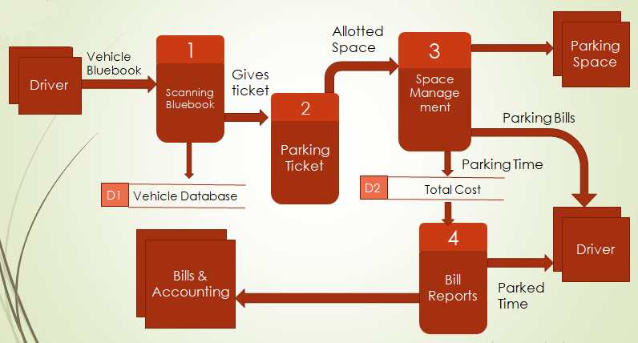

**UML DIAGRAMS**

UML diagrams provide a standardized set of tools to document the analysis and design of a software system. UML diagrams include the Case diagram and other diagrams that are derived from the Use Case diagram, such as Activity diagram and Sequence diagram.

**Use Case Diagram:**

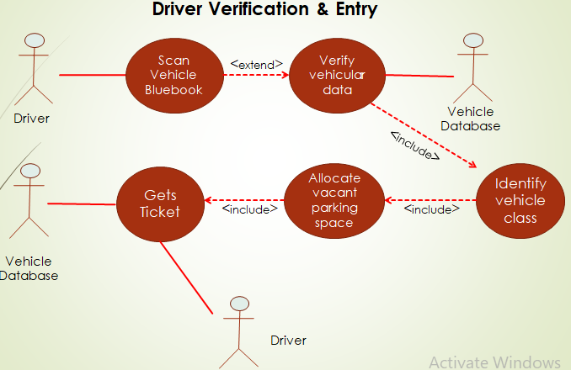

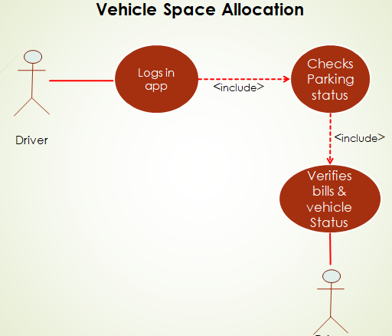

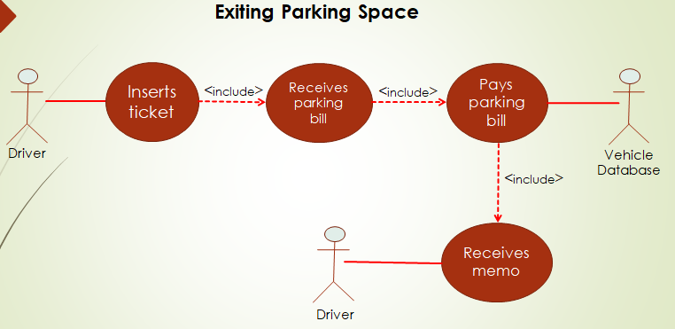

**Class Diagram:**

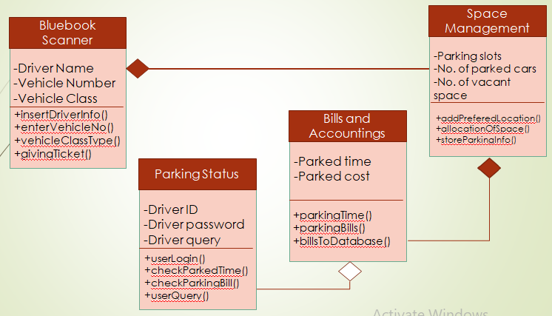

**Sequence Diagram:**

Sequence Diagrams illustrates successions of interactions between classes or object instances over time. The sequence diagram of our project is given below.

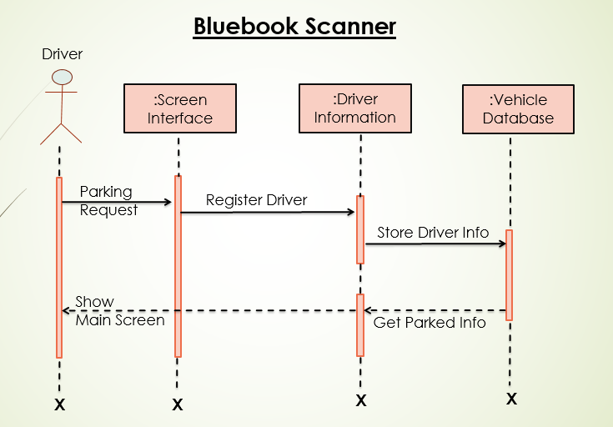

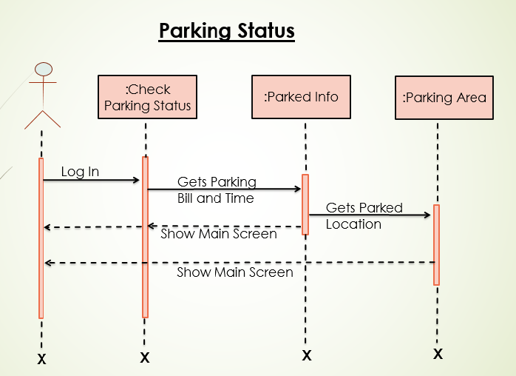

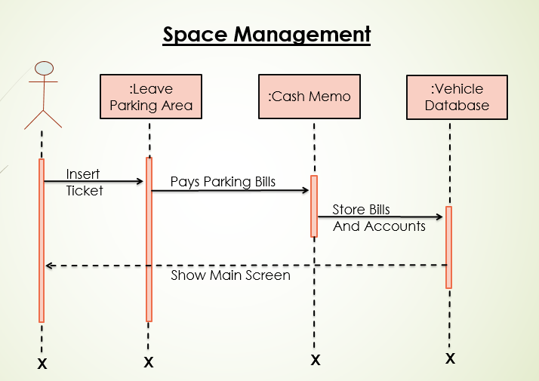

**Activity Diagram:**

Activity diagram shows the sequence of activities in a process, including sequential and parallel activities, and decisions that are made. The activity diagram of our project is given below:

